Chapter 1 - Introduction

“Nuts and Bolts” view
- Hosts = end systems
- Packet Switches == forward packets / routes / switches
- Isp = Internet Service Provider
  - They have networks inside a network core
  - A user is either connected to them or a global network
- Internet == network of networks
  - Interconnected ISP’s
- Protocols are everywhere
  - Every sent or received message has a protocol
  - HTTP (Web), streaming video, skype, wifi, ethernet, etc.
- Internet Standards
  - RFC == request for comments
  - IETF == Internet Engineering Task Force

Protocols
- Human Protocols
  - Action taken when message received
- Network Protocols
  - All communication governed by protocols
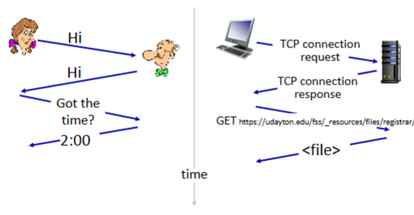

Access Networks and Physical Media
Access Network == the router in your home, the cable to the ISP provider, everything at the ISP
Why do we need it? == connect device to internet
- Cable-Bases Access
  - Spectrum == cable
  - Cable modem of my home and many others in the network all connected to a cable headend which further connected to the ISP
  - Since a whole neighborhood is hooked up, if someone downloads a lot they will slow down the whole neighborhood
  - HFC == Hybrid Fiber Coax (40 mbs - 1.2gig)
    - Called a hybrid because the homes are coax, but the cable headend uses fiber
- Digital Subscriber Line
  - Use existing telephone lines
  - Between isp and access network
- Home Network
  - Modem, router, and wifi point sit in house
  - Then you just connect to via ethernet or wireless
- Wireless
  - Connect to base station or access point
  - The base station in a house would then connect to a cell phone tower to get wifi
  - 100 ft of base station
- Wide area cellular access network
  - Phones, 4g
  - 10km of operator
- Enterprise Network
  - Mix of wired and wireless, connected with a bunch of switches and routers
- Data Center Network
  - High bandwidth
  - Hundreds to thousands of servers connected together and to internet

Packets
- Don't want to send data as a big group, instead split it up into a bunch of smaller packets
  - Why? == if you lose a massive bit of data it is a lot harder to recover it, witch small packets it is a lot easier to recover loss data
  - Why 2? == A lot of ISP’s cant send massive packets, so the only way to send large amounts of data is with smaller packets
- Host == Sending Function
  - Takes application message
  - Break into smaller chunks (packets) of length (L bits)
  - Transmit packet into access network at (transmisson rate R)
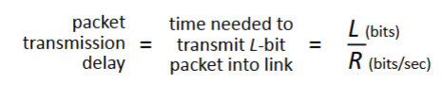
- Links == Physical Media
  - Guided Media
    - Twisted Pair (TP)
      - Two insulated copper wires
      - Category 5
      - Category 6 == faster
    - Coaxial Cable
      - 2 copper conductors
      - Bidirectional
      - broadband
    - Fiber Optic Cable
      - Glass fiber carrying light pulses, each pulse a bit
      - Very high-speed operations
      - Low error rate
      - Expensive
    - Wireless Radio
      - Signal carried in various “bands” in electromagnetic spectrum
      - No physical wire
      - Half-duplex
      - Everything can mess with it, reflections, objects in way, noise
  - Unguided Media
    - Radio Link Types
      - Wireless Lan (Wifi)
      - Wide Area (4G Cellular)
      - Bluetooth
      - Satellite
- Network Core
  - Forward packets from source to destination
  - Two key network-core functions
    - Forwarding (switching) == local action that looks at local forwarding table and then moves packets from router input link to output link
    - Routing == global action that determines source-destination paths taken by packets / a routing algorithm

Packet Switching
- Packet Transmission Delay == takes L/R seconds to transmit or push out L-bit packet into link at R bps
- 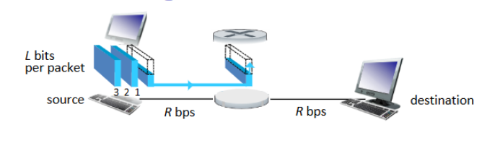
  - Transmission delay is the time it takes to push the entire packet to link
  - Transmission rate is the R bps
- Store and forward == an entire packet must arrive at the router before it can be transmitted on the next link
- 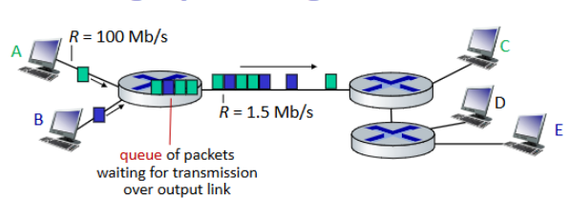
  - Would create a bottle neck because A and B are sending data too fast but it isnt leaving the next part fast enough so it creates a queue
  - Because the memory/buffer in the router fills up router can drop packets or packet-loss

Circuit Switching
- Allocate certain circuits for a connection and no one can use it
  - Guaranteed performance because no sharing
  - Its wasting it if its not in use because no one else can use it
- FDM - Frequency Division Multiplexing
  - Each call allocated to its own band and can transmit a max rate of that narrow band
- TDM - Time Division Multiplexing
  - Time divided into slots
  - Each call allocated to a periodic time slot
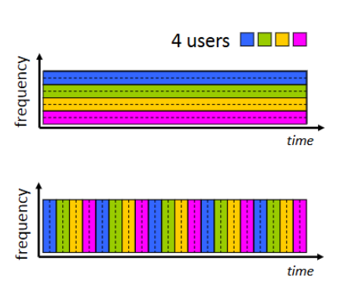
- Packet Switching vs Circuit Switching
  - 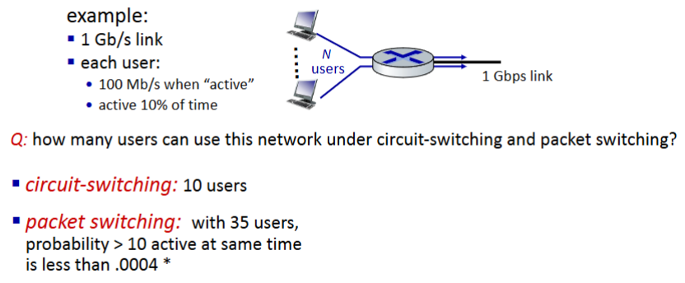
  - Packet switching can only have 10 people max at a time, but since each user is only active 10% of the time, a lot more users can use it
  - Packet switching is nice if not many people are active since the one user would get all the 1 Gb. That by theory means you can have more users
  - Packet switching is good for bursty data
  - Packet switching an give packet delay or loss and a buffer overflow, excessive congestion

Internet Structure
- Host connect to internet via access ISPs
- Access ISPs in turn must be interconnected
  - This way any two host can send packets anywhere
- Results in a massive network of networks
- How do you connect access networks to other access networks?
  - Do not connect every access net to every other access net because then you ill have O(n^2) connections which is a lot
  - Connect every access net to a global ISP which would handle all those connections for you
  - But if one global ISP is a viable business to handle that traffic, then others will appear as competitors
    - Internet companies appear and fill this void
    - These companies must connect with each other so that you can always access all traffic regardless of if they are on a different network
      - They do this through a internet exchange point or IXP
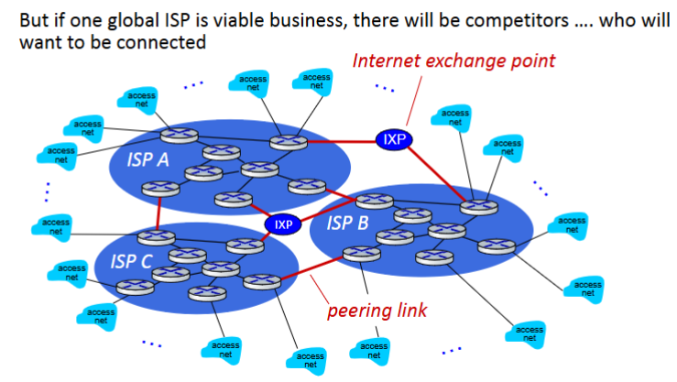
  - Regional networks may appear to connect local access nets to the ISPs
  - A content provider network such as google or microsoft may run their own network to bring services and content to end users
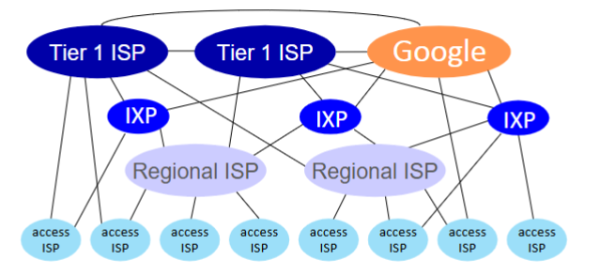
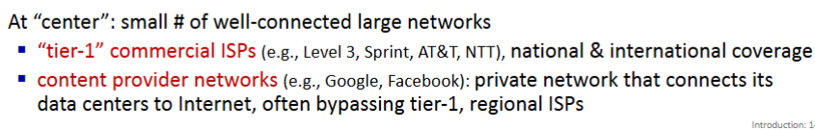

Packet Delay
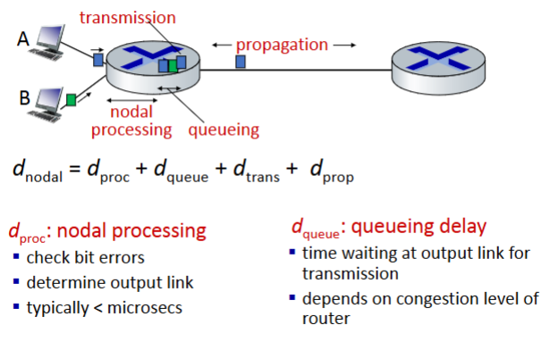

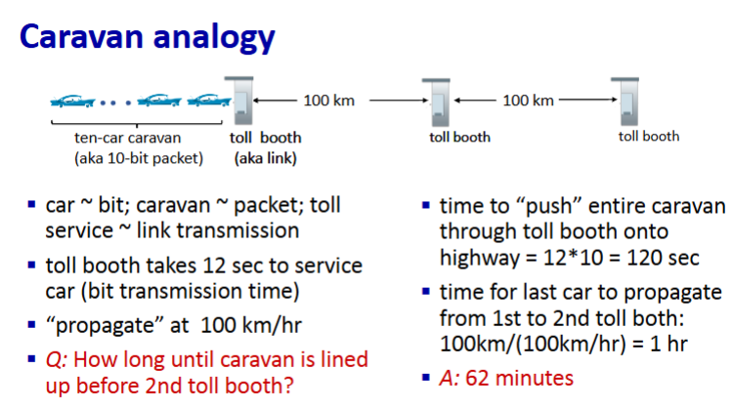
- Paket queueing delay
  - a = average packet arrival rate
  - L = packet length (bits
  - R = link bandwidth (bit transmission rate)
  - (L * a) / R = arrival rate of bits / service rate of bits
    - 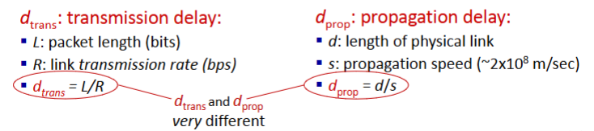Traffic intensity
    - If == 0, average queueing delay small
    - If -> 1, average queuing delay large
    - If > 1, more “work” arriving is more than can be serviced - average delay infinite
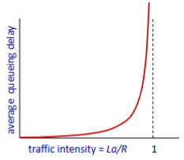
- Real internet delays and routes
  - Traceroute program == provide delay measurement from source to router along internet path towards destination
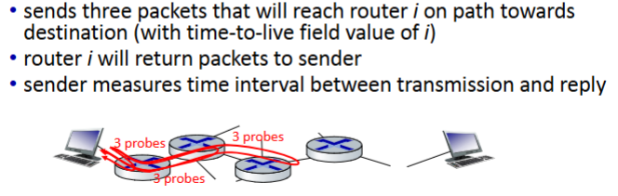

Packet Loss
- 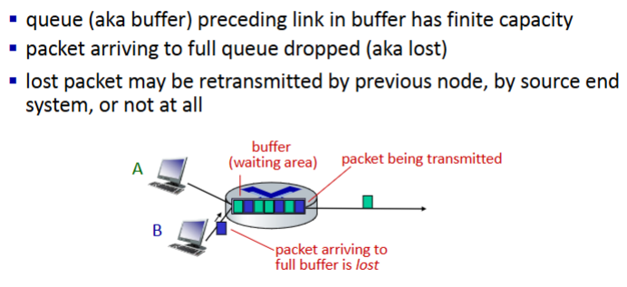
- Throughput == Rate at which bits are sent from sender to receiver
  - Instantaneous == rate at given point in time
  - Average == rate over longer period of time
  - Ex: 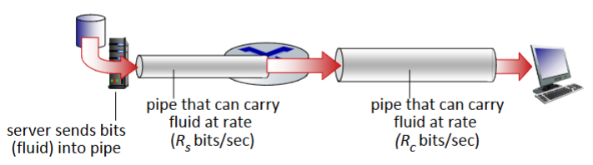
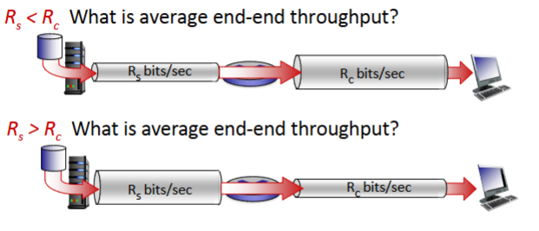
  - 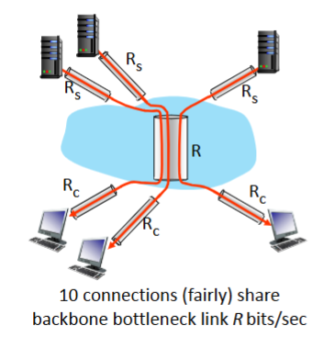
    - Throughput = min(Rc, Rs, R/K)
      - K == connections, would be 10 in above
    - Usually Rc or Rs is a bottleneck

Protocol Layers
- Air Travel end to end transfer of person + baggage Example:
  - Buy a ticket, check bag. Get on plane
  - Airplane then routes to destination
  - We then get off plane, reclaim bag, and complain about ticket
  - Each one of these things is a layer and implements a service
- Why layering?
  - Great for complex systems
  - Allows for explicit identification
- Layered internet protocol stack in order
  - Application = HTTP, IMAP, SMTP, DNS = supporting network apps
  - Transport = process to process data transfer = TCP
  - Network = routing of datagrams from source to destination = IP, routing protocols
  - Link = Data transfer between neighboring network elements = ethernet
  - Physical = bits
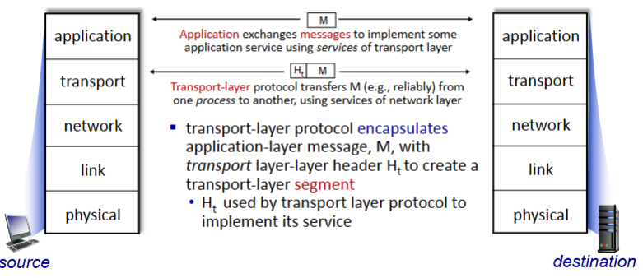
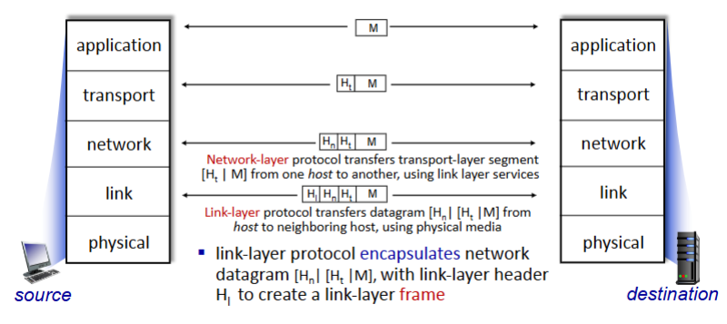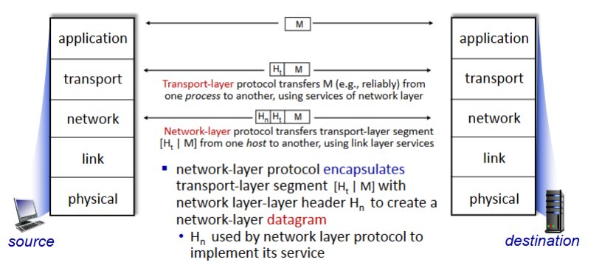

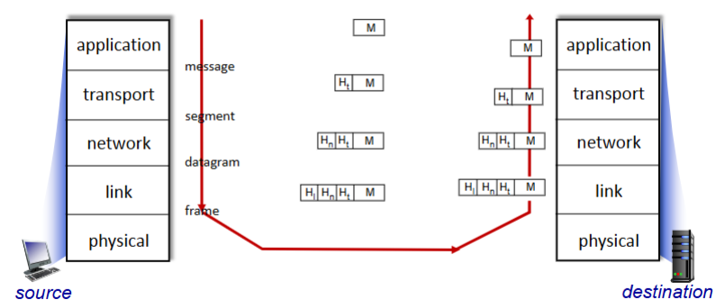
  - Basically you build a big package and send it to the destination over physical bits then break it down at the destination to each layer
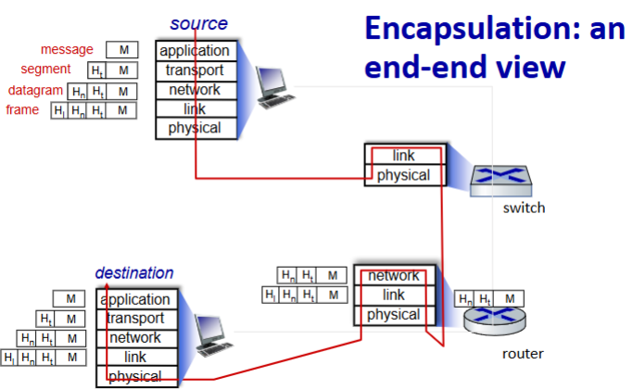
  - Goes up to the link layer, then back down to the physical layer encapsulating the link layer. Then does same thing but to the networking layer, then finally since it got the knowledge from the network layer it can send it to destination where it breaks it all down

HTTP = hypertext transfer protocol
- Web page consist of objects each stored on different web servers (html, JPEG, audio file, etc.)
- Web application-layer protocol
  - Client is the browser that request and receives web objects and displays them
  - Server is the web server that sends objects in response to request
- HTTP uses TCP
  - Client initiates TCP connection to server on port 80
  - Server accepts TCP connection
  - HTTP messages exchanged between browser(client) and web server(server)
  - TCP connection then closed
- HTTP is stateless
  - Server keeps no info from past client request
- Non-Persistent HTTP
  - TCP opened
  - At most 1 object sent over TCP connection
  - TCP closed
  - Downloading multiple objects needs multiple connections
- Persistent HTTP
  - TCP opened
  - Multiple objects sent over single TCP connection
  - TCP closed
- Persistent is better than non-persistent
- 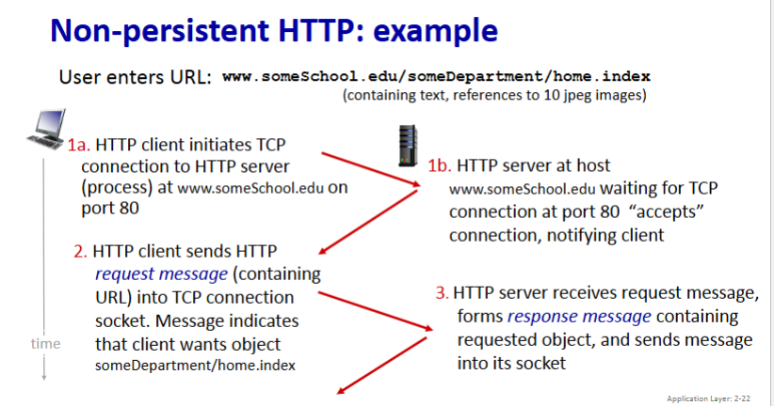
- 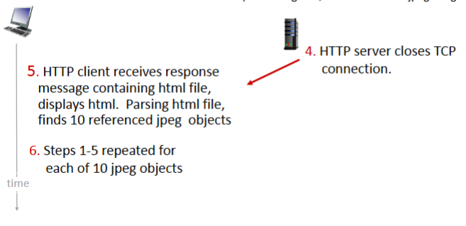
- Non-Persistent HTTP response time
  - RTT = time for small packet to travel from client to server and back = propagation delay
  - HTTP response time (per object)
    - One RTT to initiate connection
    - One RTT for HTTP request and first few bytes of HTTP request to return
    - File transmission time
  - File transmission Time = L/R
  - Non-Persistent HTTP Response Time = n *2 * RTT + file transmission time
  - Persistent HTTP Response Time = RTT + n * RTT + L/R
    - So if we have 10 transfers then non-persistent would be 20 RTT + file transfer time and persistent would be 11 RTT + file transfer time
  - 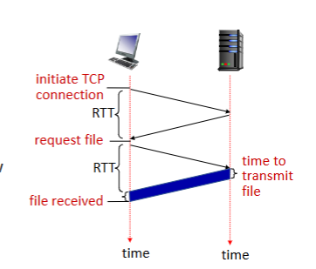
    - Client initiates a connection, then request a file, then the server sends files. Blue is the transmission time

- HTTP request message
GET /PhuPhung HTTP/1.1\r\n
Host: academic.udayton.edu\r\n
User-Agent: Mozilla/5.0 (Macintosh; Intel Mac OS X
10.15; rv:80.0) Gecko/20100101 Firefox/80.0 \r\n
Accept: text/html,application/xhtml+xml\r\n
Accept-Language: en-us,en;q=0.5\r\n
Accept-Encoding: gzip,deflate\r\n
Connection: keep-alive\r\n
  - Starts with a get message which request data
  - Then it says the host of said message and where you are sending request from
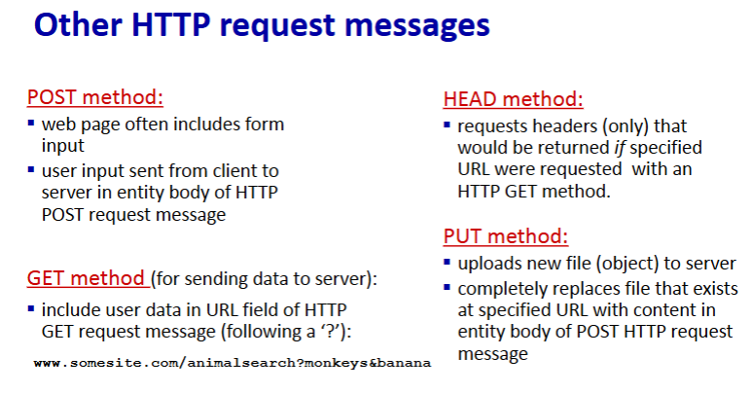

- HTTP Response Message
HTTP/1.1 200 OK
Date: Tue, 08 Sep 2020 00:53:20 GMT
Server: Apache/2.4.6 (CentOS) OpenSSL/1.0.2k-fips
PHP/7.4.9 mod_perl/2.0.11 Perl/v5.16.3
Last-Modified: Tue, 01 Mar 2016 18:57:50 GMT
ETag: "a5b-52d015789ee9e"
Accept-Ranges: bytes
Content-Length: 2651
Content-Type: text/html; charset=UTF-8
\r\n
Data data data data data
  - First line is status line
  - Rest are header lines, except data after the \r\n
  - Status codes can be sent back by server (200 OK, 404 Not Found, 505 HTTP Version Not Supported
- Maintaining User/server State
  - Cookies used to maintain user/server state
  - HTTP is stateless so it needs something to help
  - Cookie components
    - Cookie header line of HTTP response message
    - Cookie header line in next HTTP request message
    - Cookie file kept on user’s host
    - Back-end database at website
  - 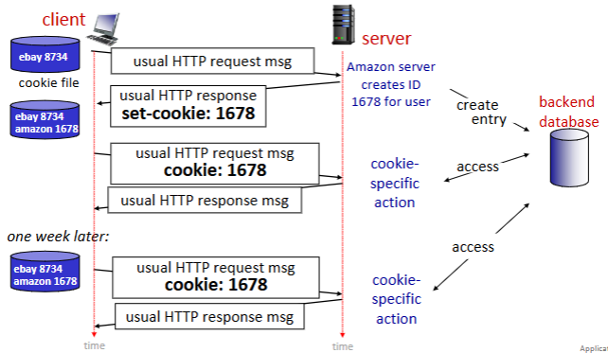
  - Cookies can be used for shopping carts, authorisation, or recommendations
  - Third party cookies shared by many websites and cause you to get targeted ads
- Web Caches (proxy servers)
  - Physically make the origin server closer to make it faster to reach it.
  - The first time you use the web cache, it will just route you through it to reach the server, but the second time it will be faster since the web cache already downloaded the server
  - Web cache is a client and server, client when it goes to server, and server when you go to it
  - Why? – – > reduces traffic on a access link, reduces response time for client request, and enables poor cont providers to deliver content more effectively
  - 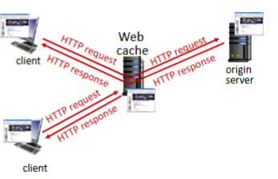
  - 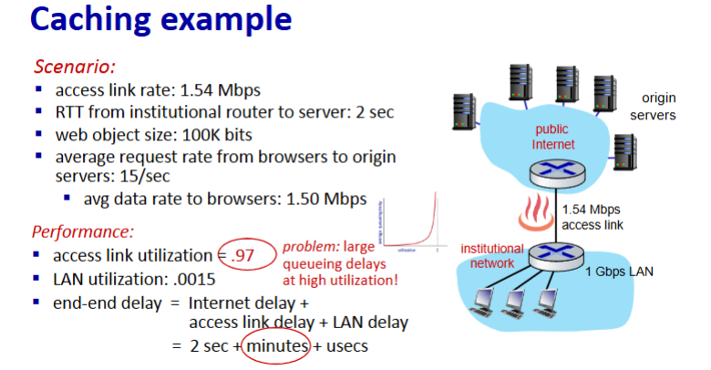
    - Access link utilisation == 1.50 / 1.54
  - End to end delay = queueing delay + transmission delay + propagation delay + processing delay
  - 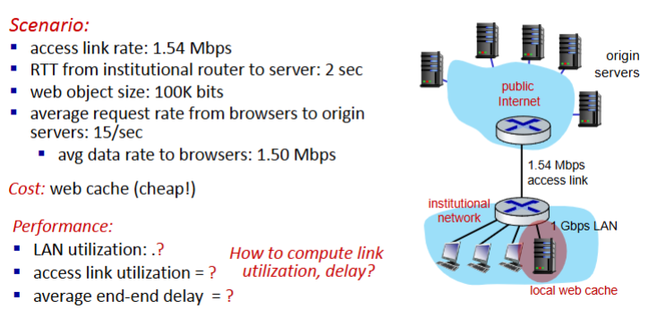
  - 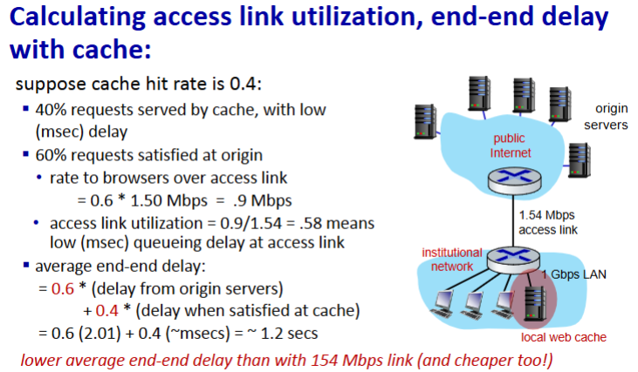
  - ^^^^^^ will be on all test
- Browser Caching
  - Goal == dont send an object if the browser has the up-t–date cached version
  - Client specifies a date of browser cached copy in HTTP request and the server will not send objects if it is up-tp-date
- HTTP
  - HTTP1.1 == introduced multiple pipelined GETs over a single TCP connection
    - Loss of objects stalls transmission
  - HTTP2 == split large objects into smaller frames, send some of object 1, then some object 2, then finish first obj
    - Basically everything is same as HTTP1 except it is now more flexible
    - No security + over 1 TCP connection
  - HTTP3
    - Adds security, per object errors, and congestion control

E-Mail, SMTP, IMAP
- E-Mail
  - Three major components
    - User Agents, Mail Servers, Simple Mail Transfer Protocol (SMTP)
  - User Agent = “mail reader”
  - Mail Server = "mailbox"
    - Client uses SMTP to send message
    - From sender to receiver we use SMTP
  - SMTP RFC
    - Use TCP to transfer email messages from client to server
    - Three phases of transfer
      - SMTP handshaking / greeting
      - SMTP transfer of messages
      - SMTP closure
S: 220 hamburger.edu
C: HELO crepes.fr
S: 250 Hello crepes.fr, pleased to meet you
C: MAIL FROM: <alice@crepes.fr>
S: 250 alice@crepes.fr... Sender ok
C: RCPT TO: <bob@hamburger.edu>
S: 250 bob@hamburger.edu ... Recipient ok
C: DATA
S: 354 Enter mail, end with "." on a line by itself
C: Do you like ketchup?
C: How about pickles?
C: .
S: 250 Message accepted for delivery
C: QUIT
S: 221 hamburger.edu closing connection
    - HTTP pulls client, SMTP pushes client
    - Requires message to be in 7-bit ASCII
    - Persistent Connections
  - Mail Message Formal
    - SMTP == protocol for exchanging email messages defined in RFC 5321
    - TFC 2822 defines syntac for email messages itself
    - 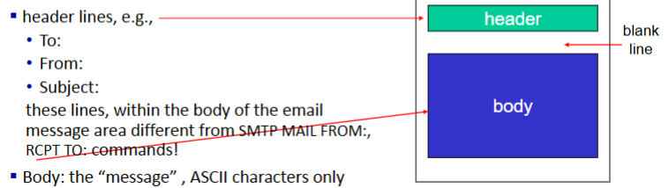
    - 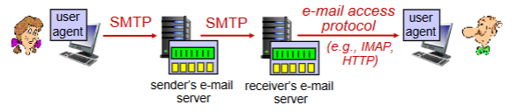
      - Internet Mail Access Protocol == IMAP = retrieval, deletion, and folders all stored on server

DNS - Domain Name System
- DNS is like SSN for the internet (IP address)
- IP address is used for internet while we use the website name
  - How are those names and IP’s mapped together? → DNS
- Distributed database implemented in a hierarchy of many name servers
- Application-layer protocol: host, DNS servers communicateto resolve names
- DNS uses UDP port 53
  - HTTP is port 80
  - TCP is port 21
- Why not contralise DNS? → it doesnt scale
  - Too much traffic and we don’t want a single point of failure
- 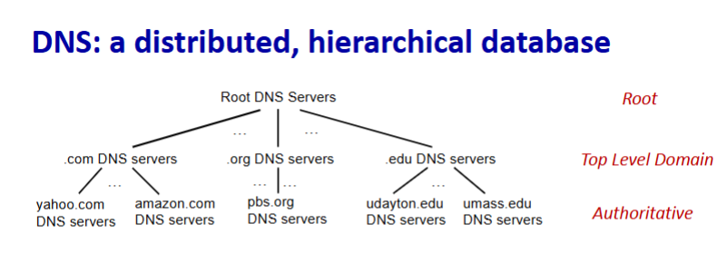
- Lets say we want ip address for www.amazon.com
  - Client queries root server to find .com DNS server
  - Client queries .com DNS to find amazon.com DNS server
  - Client queries amazon.com DNS for ip address
- 13 logical root name “servers” worldwide with each server replicated many times
- Top-level Domain
  - Responsible for .com, .edu, .net, etc.
- Authoritative DNS Servers
  - Organisations own DNS server(s)
  - Can be maintained by organisation or service provider
- Local DNS Servers
  - Doesn’t strictly belong to a hierarchy
- 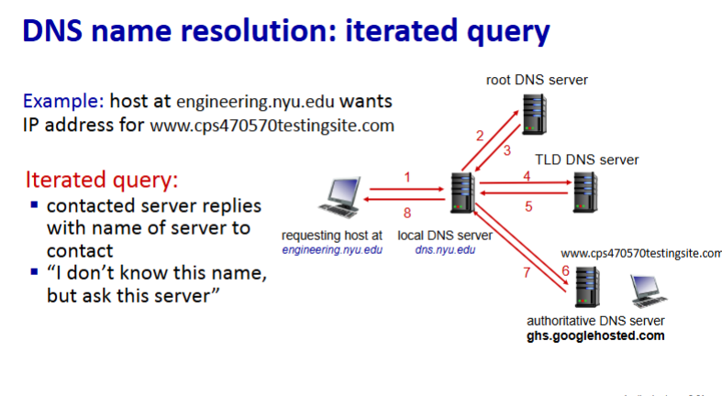
- 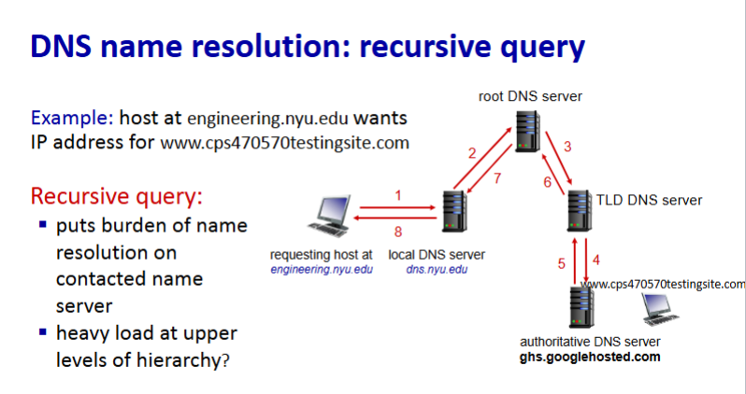
  - Iterated query is more used in real life since recursive has waaaay to high a load

- DNS records
  - Resource records (RR) = distributed database for storing DNS info == format → (name, value, type, ttl)
  - Type A
    - Name is hostname
    - Value is IP
  - Type NS
    - Name is domain ( eg. foo.com)
    - Value is hostname of authoritative name server
  - Type CNAME
    - Name is alias for some other name (ibm.com is really servereast.backup2.ibm.com)
    - Value is canonical name
  - Type MX
    - Value os name of SMTP mail server associated with name
    - Basically the mail type
  - 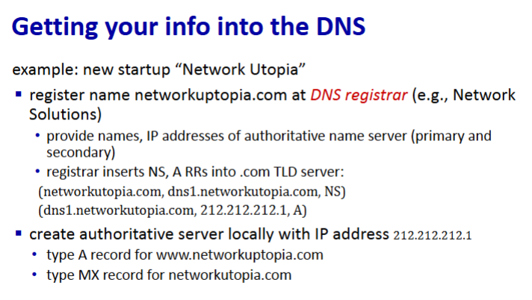
    - Registrar provides name and IP address
    - Registrar inserts NS and RR into .com
- Video streaming
  - Challenge, too many users, too biig
  - Challenge, users are too different from each other, everyone has different capabilities
  - Solution == distribution application level infrastructure
  - To make it easier to stream a video, use redundancy within and between images to decrease bits
    - Encoding
    - CBR (constant bit rate) → video encoding fixed rate
    - VBR (variable bit rate) → video encoding changes as amount of spatial temporal and coding changes
    - Examples
      - CD-ROM → MPEG1 → 1.5 Mbps
      - DVD → MPEG2 → 3-6 Mbps
      - MP4 → MPEG4 → 64 Kbps - 12 Mbps
  - 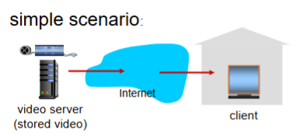
    - Server to client bandwidth will vary over time with differing congestion levels
    - Packet loss can occur and delay the video or lower quality
  - 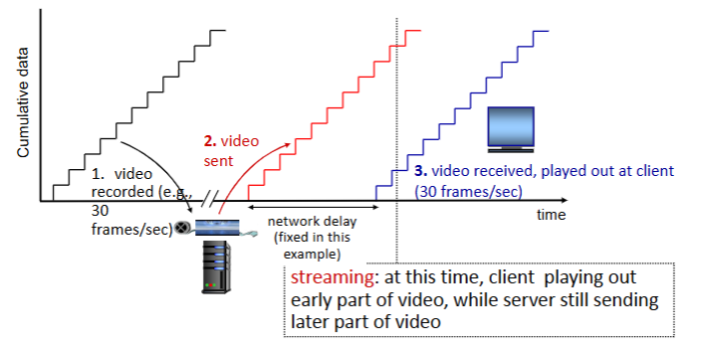
  - We need continuous play of a video without stopping
    - Implement buffering or delays on the user. This will make it so the user waits for the video to get ahead of them
    - This also allows us to delay the user when they fast forward, or to load when they pause
    - 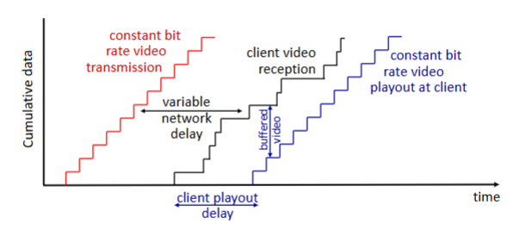
  - Sometimes network delay is just too large tho and you need to find a middle ground for it to be usable
    - DASH == Dynamic Adaptive Streaming over HTTP
    - Server divides file into multiple chunks and encodes each chunk at different rates stored in different files
    - Files represented in CDN nodes and use a manifest file with urls to access them
    - Client consults the manifest and requests 1 chunk at a time, choosing the best coding rate usable given the current bandwidth. It can choose different coding rates at different chunks, its goal is just to stay consistent.
    - Client is the intelligence, it decides when, what rate, and where to request chunk
  - Streaming video = encoding + DASH + playout buffering
- Content Distribution Network (CDN)
  - Store multiple copies of videos at multiple geographically distributed sites
  - Makes it faster and easier for clients to get data
  - 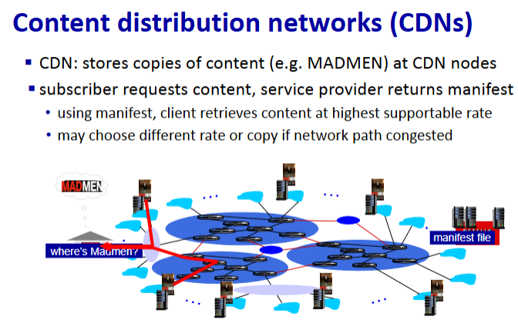
    - OTT (over the top) service
    - Only issue is deciding what content to place at each CDN node

Socket Programming with UDP and TCP
- Socket is like an interface between server and client
- 2 socket types for 2 different transport services
  - UDP = unreliable datagram
    - No connection between client and server
    - We use on internet not for this type of thing
  - TCP = reliable, byte stream-oriented
- 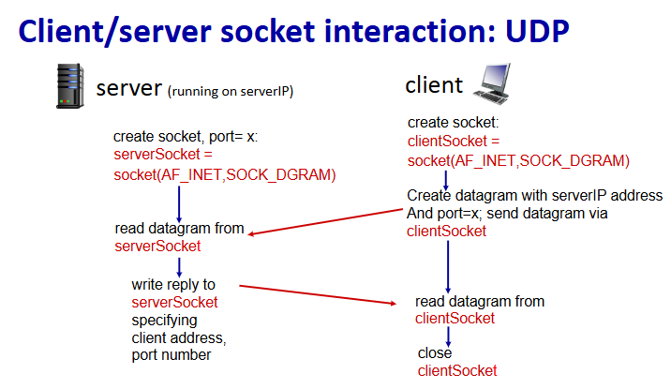
- 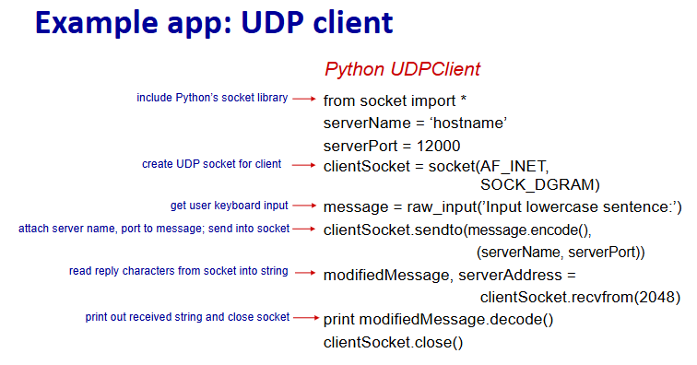
  - SOCK_DGRAM tells us we are using UDP
  - For a socket we need an ip and a port number, yet we dont specify a port number
    - The reason is because it is generated randomly
    - You can designate a specific port if need be
- 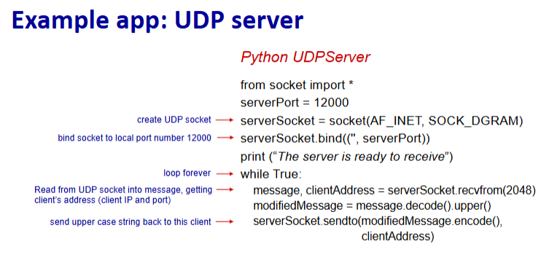
  - Must specify port for server
- Cmd prompt stuff
  - Ipconfig → look at en0, remember the inet Ip address
- Socket programming with TCP
  - TCP will create a new socket for each client that connects to server
  - 
   